**Defect log**

|  |  |
| --- | --- |
| Defect id | **D001** |
| Test Case ID | **TC_001** |
| Raised By | **Saurav Basak** |
| Module Name | **Selenium Videos** |
| Priority |  |
| Date | **17-02-2021** |
| Defect Summary | **On clicking the keynote session button, a dialog box appeared which is asking to fill the required fields along with a human verification.** |

**Screenshots:**

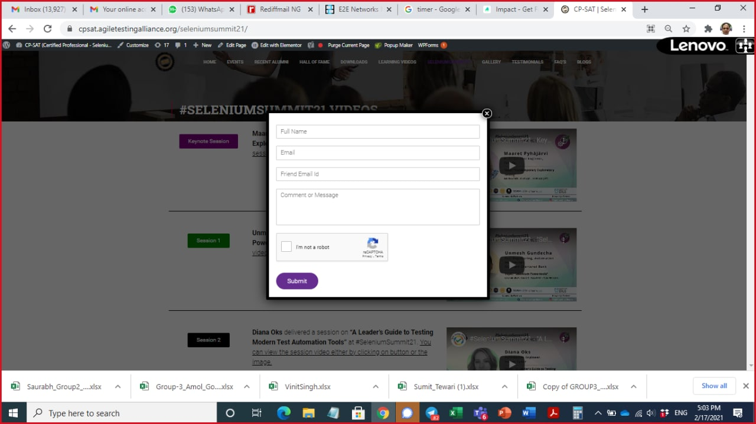

On the homepage, we can see the first “keynote session” button along with the first video. After clicking it, I found out that a dialog box appeared which was not supposed to be. It is supposed to redirect to [www.youtube.com/video_url](http://www.youtube.com/video_url) in a new tab. The dialog box is asking to enter details in some fields along with a human verification checkbox. Resolve the issue as soon as possible!